# Lab: Strings and Text-Processing

Problems for in-class lab for the [“Technology Fundamentals” course @ SoftUni](https://softuni.bg/trainings/2056/technology-fundamental-september-2018#lesson-9635).

Submit your solutions in the SoftUni judge system at: [Strings-and-Text-Processing-Lab](https://judge.softuni.bg/Contests/1194/Strings-and-Text-Processing-Lab)

## Print Characters

Write a function that receives a string and prints all the characters on separate lines.

### Examples

|  |  |
| --- | --- |
| **Input** | **Output** |
| 'AWord' | A  W  o  r  d |

### Hints

Loop through the string and print each character.

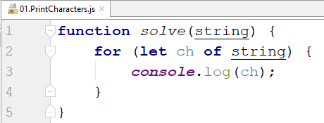

## Concatenation

Write a function that receives an array of strings and prints a resulting string containing all of them.

### Examples

|  |  |
| --- | --- |
| **Input** | **Output** |
| ["First",  "Second",  "Third"] | FirstSecondThird |

### Hints

Loop through the array and concatenate the current element to a resulting string.

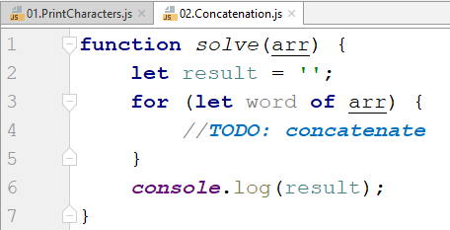

## Substring

Write a function that receives a string and two numbers. The numbers will be a starting index and count of elements to substring. Print the result.

### Examples

|  |  |
| --- | --- |
| **Input** | **Output** |
| "ASentance", 1, 8 | Sentance |

### Hints

Create a new string that takes the needed amount of elements from the given string.

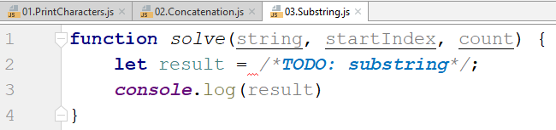

## Censored Words

Write a function that receives a text and a word. Find all occurrences of that word in the text and replace them with the corresponding count of '*'.

### Examples

|  |  |
| --- | --- |
| **Input** | **Output** |
| "A small sentence with some words", "small" | A ***** sentence with some words |

### Hints

Save the new text in a new variable.

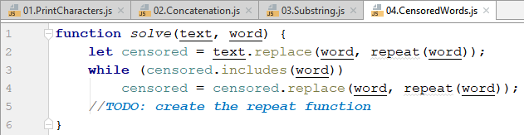

The repeat function should take the length of the word and return that amount of stars '*'.

## Count string occurrences

Write a function that receives a text and a string to search for. Print all the occurrences of that word in the string.

### Examples

|  |  |
| --- | --- |
| **Input** | **Output** |
| "This is a word and it also is a sentence",  "is" | 2 |

### Hints

Split the sentence into words and create a counter that stores how many times the searched word occurs.

